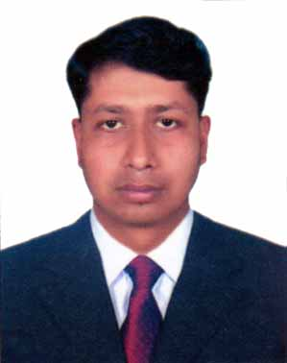**RESUME  
OF**

**SUVANKAR BISWAS**

**C/o:Subol Chandra Biswas  
Vill:Kamta, Po:Shemulia  
Ps:Debhata, Dist:Satkhira  
Cell : 01821 128599**

**E-mail:suvankarbis22@gmail.com**

**To pursue a challenging job in a dynamic and esteemed organization where I will be able to work in any kind of situation with full efforts to utilize my knowledge, skill and experience for professional career development.**

**Personal Information :**

Name : Suvankar Biswas.

Father’s : Subol Chandra Biswas

Mother’s : Lakhmi Rani.

Date of Birth : 17/03/1986

Nationality : Bangladeshi

Religion : Hindu.

Marital : Un-Married

National Id : 8712547569539

**Address:**

Permanent Address : Suvankar Biswas  
 C/o- Subol Chandra Biswas  
 Vill- Kamta,

Po- Shemulia  
 Ps- Debhata,

Dist- Satkhira

Present Address : Suvankar Biswas, Thaingkhali, Ukhiya, Cox’s Bazar.

**Educational Qualification:**

**Master’s of Business Studies(M.B.S)**

College : Satkhira City College,Satkhira.  
Subject : Accounting   
Division Obtained : First Class.

Passing Year : 2010  
Examination : National University Gazipur.

**Bachelor of Business Studies(B.B.S Honors)**

College : Satkhira Govt College, Satkhira.  
Subject : Accounting   
Division Obtained : Second Class.

Passing Year : 2009

Examination : National University Gazipur.

**Higher Secondary Certificate Examination (H.S.C)**

College : Khan BahadurAhsanullah College.Passing year : 2004  
Group : Business StudiesGPA Obtained : 4.10 Out of 5.00.Examination : Board of Intermediate andSecondary Education

Jessore.

**Secondary School Certificate Examination (S.S.C)**

School : Sakhipur Secondary School  
Passing year : 2002  
Group : Business Studies  
GPA Obtained : 3.00 Out of 5.00.  
Examination : Board of Intermediate and Secondary Education

Jessore.

**Computer Skill** **:** Computer in office Application Course 06 Month

(Ms-Word, Ms-Excel, Ms-Accessand Ms- Power Point etc)

**Experience:**

1. One year experience in rohinga camp as a post of program orgasnizer of child protection program in brac.
2. Two years experience in a Program Organizer of Skill Development Programme (SDP) at brac.

**Reference:**

2. Samoresh Roy

Asst. Professor

Deptof Philosophy

Bohera Mohila College Khulna.

Cell No: 01718 249433

1. Swapan Kumar Ghosh.

Asst. Professor

Dept of Accounting

Satkhira Govt. Mohila College

Cell No: 01719 504054



Date: Applicant Signature: